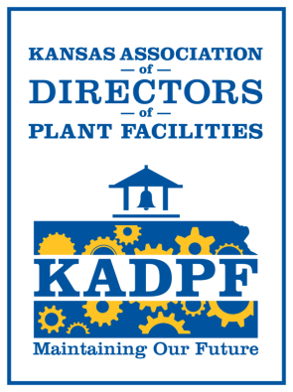
President Scholarship Director Secretary
Matt Davis Jeff Arnold Trisha Brooke-Fruendt
USD 383 – Manhattan-Ogden USD 489 Hays USD 383 – Manhattan-Ogden
2031 Casement Road 323 W 12th Street 2031 Casement Road
Manhattan, KS 66502 Hays, KS 67601 Manhattan, KS 66502
(785) 587-2180 (785) 623-2420 (785) 587-2180
MatthewD@usd383.org rlindsay@usd489.com patriciab@usd383.org

Building Maintenance • Grounds Maintenance • Custodial Management • Student Transportation
Operations Efficiency • Environmental Safety • Leadership & Supervision

KADPF Presentation Proposal/Sponsorship
To promote and maintain personal improvement by providing educational programs to increase the knowledge of methods, materials and equipment for the operation and the maintenance of buildings and grounds; raise the standards of building maintenance and for continued fellowship the KADPF board would like to request a proposal for presentation topics, speakers or sponsorship for the 2021 KADPF conference. Please feel free to pass this upward to manufactures, engineers or other resources that may provide valuable education opportunities.
Benefits for presenter include access to over fifty plant and facility directors involved in K-12 and post-secondary education. Additionally you will have an opportunity to network at the conference, support the scholarship program, and potentially purchase ad space in the KADPF magazine.
Upon submission, the proposals will be reviewed and discussed by the KADPF board for selection by the board for those proposals that best fit into today’s needs for facility managers. These proposals may become part of the selection of presenters or educational opportunities for the 2021 conference.
Presentations should be:
- 20-30 minutes long for round table discussions OR 45 minutes for presentations
- Industry “Best Practice” NOT business specific sales presentations
- Current to today’s trends or changes in facility management
- Diverse- Topics should range from hands on knowledge to management tools
- Offer take away items, one or two points that stick to audience
- Professional in content
Additionally, the KADPF board would seek any vendor that would be interested in sponsoring different items during the event. These options include:
- Sponsor a new attendee (cover registration fees)
- Sponsor or partial sponsor of Sporting Clays tournament (Sunday Afternoon)
- Partial or entire sponsorship of snack or beverages during conference
- Partial or entire sponsorship of receiving event at the bar (Sunday Evening)
- Partial or entire sponsorship of social hour at the bar (Monday Evening)
- Sponsor raffle, sporting clays items
- Magazine article
If you are interested please fill out the form and return to: MatthewD@usd383.org or RoseD@hutchcc.edu, no later than May 1, 2021.

Please fill out and return or attach to proposal

I am interested in… (Check all that apply)
- Round table presentation □

- General session presentation □

- Sponsoring one new attendee

I have someone in mind
Open sponsorship as needed
- Sponsor snack or beverage cart – yes or no
Max value $
- Sponsor banquet or social hour – yes or no
Max value $
- Providing a raffle or sporting clay prize item (s)

Business/Contact information:
Name:
Address:

Phone/email:

Topic:

Brief description of presentation outline:

Participants take away:

Cost associated if any:

